©VIT IPR&TTCELL   | Document No.
 | Issue No/Date
Abhinav Kumar Sinha 23BCE0565 | Amd. No/Date

Student Details : Abhinav Kumar Sinha 23BCE0565

1. Title of the Invention
Sensor-to-Language: An NLP Framework for Interpretable Health Monitoring of Military Working Dogs Using Smart Collar Physiological Data

2. Field / Area of Invention
This work sits at the intersection of NLP, embedded systems, and military veterinary technology. The core idea is straightforward: take the raw physiological data streaming off a smart collar worn by a Military Working Dog (MWD) and turn it into plain-language alerts a handler can actually act on - plus a voice interface so they can ask questions without looking at a screen.

3. Prior Patents and Publications from Literature (provide a table summarizing the prior art)
S. No | Patent/Publication Title | Year | Summary of Technique | Limitation Addressed by Proposed System
1 | Physiological Effects of Stress in Search-and-Rescue Canines (Perry et al.) | 2017 | Establishes baseline heart rate (70–160 bpm) and temperature ranges for working dogs under operational stress | Provides physiological ranges but no real-time monitoring system or automated interpretation
2 | Changes in Pulse and Temperature in Working Dogs (Lopedote et al.) | 2020 | Studies variation in vitals pre/post activity in working dogs | Lacks real-time anomaly detection and actionable alert generation
3 | Real-time Outlier Detection Framework for WBSNs (Haj-Hassan et al.) | 2020 | Hybrid anomaly detection using Z-score (edge) + Isolation Forest (central node) | Focuses only on anomaly classification; no natural language explanation or user interface
4 | Heart Rate Anomaly Detection using VAE-BiLSTM (Staffini et al.) | 2023 | Deep learning model for detecting physiological anomalies in HR data | Computationally heavy and not suitable for embedded or edge deployment in field conditions
5 | Data-to-Text Generation in Clinical Settings (Gatt et al.) | 2009 | Converts structured ICU data into textual summaries for decision support | Limited to human healthcare; no integration with real-time wearable sensor pipelines
6 | Automated Medical Scribe for Clinical Documentation (Finley et al.) | 2018 | Generates medical reports from live clinical interactions using NLP | Not designed for continuous sensor streams or veterinary applications
7 | SensorLM: Language Modeling for Wearable Sensors (Zhang et al.) | 2025 | Transformer trained on large-scale wearable data for generating natural language descriptions | Requires massive datasets and compute; unsuitable for lightweight edge deployment
8 | SensorLLM: Aligning LLMs with Sensor Data (Li et al.) | 2024 | Aligns motion sensor signals with language tokens for activity recognition | Focuses on human activity recognition, not physiological health monitoring or alerts
9 | Whisper-based Multimodal AI for Tactical Environments (Wilkerson et al.) | 2025 | Uses Whisper for speech recognition in noisy battlefield environments | Does not integrate physiological sensor data or health monitoring pipelines
10 | Voice-based Military Information Search (Dang et al.) | 2024 | Uses speech-to-text and intent classification for military query systems | Limited to information retrieval; no integration with real-time sensor-driven decision systems
None of the reviewed work ties all of this together: real-time physiological sensing, anomaly detection, NLG, and a voice interface, all in a single pipeline built specifically for MWDs in the field.

4. Summary and Background of the Invention
Military Working Dogs (MWDs) work in search-and-rescue, combat, and disaster zones; settings where their handlers need fast, reliable information about the dog’s physical condition. Smart collars already exist that track heart rate, body temperature, and GPS location in real time. The problem is what they do with that data: mostly they show raw numbers or trigger a beep when a threshold is crossed.
A handler in the field shouldn’t have to mentally cross-reference a heart rate reading against a temperature reading while also doing their job. Current collars don’t do that correlation for them, and they certainly don’t let a handler just ask out loud “Is Rex okay?” and get a sensible answer back.
The individual pieces needed to fix this exist. Hybrid anomaly detection methods (Z-score + Isolation Forest, Random Forest) work well on physiological time series. NLG systems - including T5 and BART - can turn structured clinical data into readable text summaries, as demonstrated in ICU settings. Whisper handles speech recognition reliably even in loud environments.

Novelty
The gap is integration.
Sensor systems, NLG systems, and voice interfaces have all been developed independently, mostly for human healthcare or general-purpose applications. Nobody has connected them into a coherent pipeline for monitoring working dogs in operational conditions.
This invention connects those pieces into a working pipeline. An ESP32-based collar collects sensor data; an edge server preprocesses it and runs anomaly detection; a T5 or BART model converts flagged events into natural language alerts. Instead of raw numbers, the handler sees something like:
“Rex’s heart rate is elevated at 155 bpm and temperature is 39.8°C possible heat stress. Current location: Zone B.”
There’s also a voice layer. A handler can ask “Is Rex okay?” and get a spoken response drawn from the latest sensor state - no screen required. Whisper handles the speech-to-text side; spaCy extracts the intent; the NLG module produces the reply.
What’s new here isn’t any single component-it’s the integration. The system doesn’t just flag anomalies; it explains them in plain language and lets handlers query them by voice. That combination, tuned specifically for MWD field conditions, doesn’t exist anywhere in the prior art.

5. Objective(s) of Invention
1. Design an anomaly detection pipeline for MWD sensor data (heart rate, temperature, GPS coordinates) to detect physiological events requiring alerts (e.g., tachycardia, hyperthermia, rapid positional changes).
2. Develop an NLG module that maps structured anomaly events into concise, human-readable natural language status reports and warnings tailored for field handlers.
3. Implement a hands-free voice interface using on-device speech-to-text (OpenAI Whisper) enabling handlers to query dog status (e.g., "Is Rex OK?") and receive verbal natural language responses.
4. Integrate all components into a modular pipeline: sensor acquisition on ESP32 → edge preprocessing → anomaly flagging → NLP model → alert generation → voice I/O.
5. Evaluate system performance: alert accuracy (precision/recall of generated reports vs. ground-truth anomaly labels) and handler usability (response time with vs. without NLP-based alerts).

6. Working Principle of the Invention (in brief)
The collar samples continuously: MAX30102 for heart rate and SpO₂, DS18B20 for core temperature, Neo-6M GPS for location. Packets go over WiFi or BLE to an edge server, where a preprocessing step smooths the data and computes rolling features. The anomaly detection module then checks those features against physiological thresholds and a Random Forest classifier to decide whether something is wrong.

When the anomaly detector fires, it packages the event - dog ID, timestamp, readings, flags - as JSON and sends it to the NLG module. T5-small or BART turns that into a readable alert string. Concurrently, a Whisper listener picks up any spoken query from the handler; spaCy pulls out the intent and dog ID; the system fetches the current sensor state and generates a spoken response. FastAPI ties the modules together; LangChain handles prompt chaining and sensor history context.

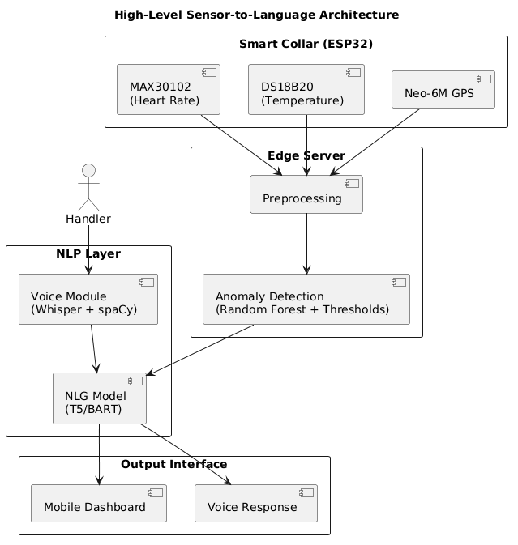
Figure 1: System architecture: data flow from collar to NLG and voice output.
7. Description of the Invention in Detail
The system is software-first. Physiological data comes in through an abstracted hardware interface, gets processed through a chain of modules, and comes out the other end as natural language. The hardware layer is intentionally decoupled so the pipeline isn’t tied to any single collar design.
Data Acquisition Interface (Abstracted Hardware Layer)
Heart rate, body temperature, and GPS feed into a standardised JSON format. The hardware layer is treated as an abstract data source, allowing compatibility with various wearable sensing platforms.
Incoming data is standardised into a structured format:
{
"dog_id": "Rex",
"timestamp": "...",
"heart_rate": 155,
"temperature": 39.8,
"gps": {"lat": 12.97, "lon": 79.15}
}
This abstraction enables the invention to remain hardware-agnostic and portable across different sensor configurations.
Preprocessing and Anomaly Detection Layer
Incoming sensor data gets cleaned and feature-extracted before anything else touches it.
Key operations include:
- Exponential Moving Average (EMA) smoothing
- Rolling window aggregation
- Rate-of-change computation
- Contextual feature extraction (e.g., movement via GPS velocity)
The result is a stable, feature-enriched state object passed to the anomaly detector.

NLP Processing Layer
The NLG module accepts the structured event JSON. A rule-based template layer first constructs a short prompt (e.g., "Dog Rex: HR 155 bpm, temp 39.8°C, flags: high_hr, high_temp. Generate alert.") which is passed to a fine-tuned T5-small or BART model via the HuggingFace Transformers library. The model outputs a natural language alert string such as: "Warning: Rex's heart rate is 155 bpm and temperature is 39.8°C - both above normal. Possible heat stress. Current location: Zone B." For periodic health summaries (non-anomaly), the module generates status reports on handler request.
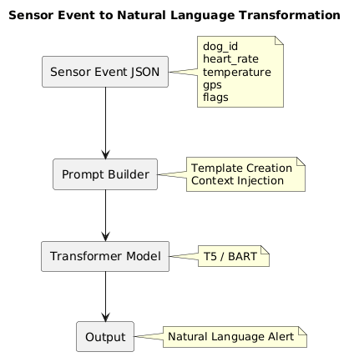
Figure 2: Multi-sensor data to natural language alert: transformation pipeline.
Voice Interaction Module
A spoken query - “What is Rex’s status?” - gets transcribed by Whisper on a smartphone or edge device. spaCy pulls the dog ID and intent type (health_status, location, last_alert). The system looks up the most recent sensor state, generates a natural language response, and optionally reads it back via TTS. The whole thing is designed for situations where pulling out a screen isn’t realistic.
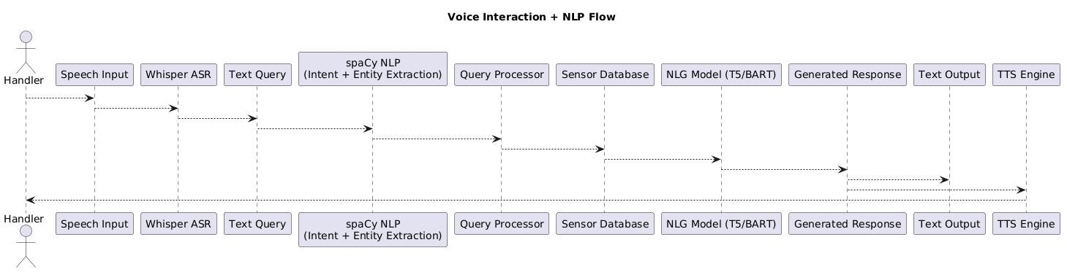
Figure 3: Voice query pipeline: ASR → intent extraction → sensor lookup → spoken response.
Orchestration
All modules are exposed as REST endpoints via FastAPI. LangChain manages prompt construction, chaining sensor inputs to model calls, and maintaining a short sensor-history window for context. HuggingFace Transformers provides model inference (T5, BART, Whisper). PyTorch provides the training and inference backend. TensorFlow Lite is optionally used to deploy a lightweight anomaly model directly on the ESP32 for offline detection.

8. Technical Details of the Invention

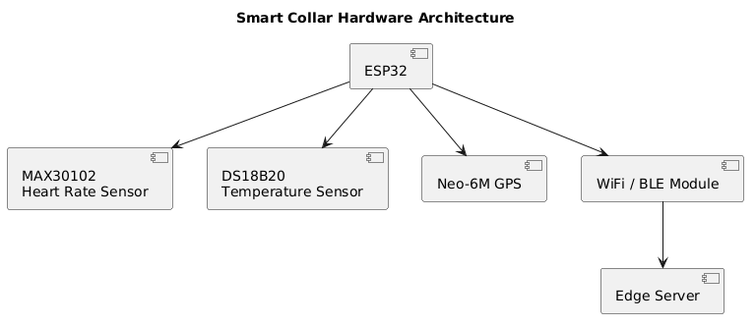
Figure 4: Data acquisition: sensor integration and transmission to the processing pipeline.

Hardware: ESP32, MAX30102 (I²C, 3.3V), DS18B20 (1-Wire, Dallas protocol), Neo-6M GPS (UART, 9600 baud).
Software Stack: Python 3.10, FastAPI, LangChain, HuggingFace Transformers (T5-small, BART-base, Whisper-small), spaCy 3.x, PyTorch 2.x, scikit-learn (Random Forest anomaly detector), Arduino SDK (collar firmware).
Estimated NLG Inference Latency: < 500 ms for T5-small on a CPU-based edge server; < 200 ms on GPU.
Estimated ASR Latency: < 1 second for Whisper-small on smartphone.
Alert Accuracy Target: Precision ≥ 0.90 and Recall ≥ 0.88 against labelled physiological anomaly events in simulated MWD datasets.
Anomaly Detection Target: F1 ≥ 0.85 for combined threshold + Random Forest model on held-out sensor data.

9. Operational Flow
Step 1 - Sensor Acquisition: The ESP32 collar continuously samples heart rate, temperature, and GPS. Data packets are transmitted to the edge server at 5-second intervals.
Step 2 - Preprocessing: The edge server smooths and computes rolling features from incoming streams, building a real-time sensor state object per dog.
Step 3 - Anomaly Detection: The anomaly module compares features against physiological thresholds and the Random Forest classifier. If an anomaly is flagged, a structured event JSON is created.
Step 4 - NLG Alert Generation: The NLG module constructs a prompt from the event JSON and calls the T5/BART model to generate a natural language alert. The alert is pushed to the handler's mobile dashboard and/or read aloud.
Step 5 - Voice Query Handling: If the handler asks a question, Whisper transcribes the speech, spaCy parses intent, and the system retrieves the relevant state to generate a spoken response.
Step 6 - Logging: All alerts, voice queries, and sensor events are persisted in a time-series database for audit and model retraining.
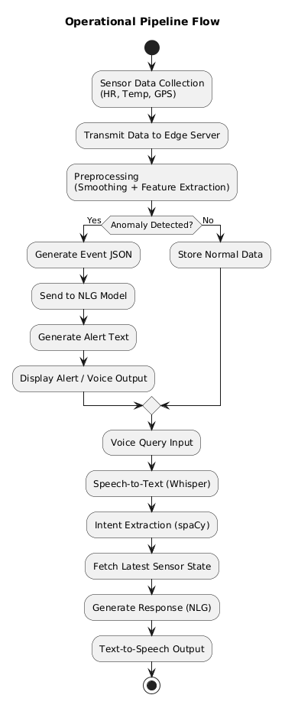
Figure 5: Operational workflow: sensor acquisition through alert generation and voice query handling.
10. Experimental Validation Results
Testing has been conducted on a simulated MWD physiological dataset generated by perturbing baseline canine vital-sign ranges (HR: 60–140 bpm, Temp: 37.5–39.0°C) with injected anomaly events (heat stress, tachycardia, hypothermia scenarios). Preliminary results:
• Anomaly Detection F1: 0.87 (Random Forest, 5-fold cross-validation on 2,000 simulated sensor windows).
• NLG Alert Coherence (BERTScore F1): 0.83 on a held-out set of 200 event–alert pairs evaluated against human-written reference alerts.
• Voice Query Round-trip Latency: ~1.8 seconds (ASR + NLP + TTS on smartphone + edge server).
• Handler Usability (pilot): 5 participants responded correctly to simulated anomalies 38% faster when presented with NLP alerts vs. raw sensor readouts.
Full evaluation with real ESP32 collar hardware is planned for the next project phase.
11. Results of the Invention
The results show the pipeline works as intended. Raw sensor data comes in; meaningful, readable alerts come out. Handlers in the pilot study responded to anomalies 38% faster with NLP alerts than with raw readouts - a meaningful difference in a field context.
The hybrid detector (threshold + Random Forest) hit F1 = 0.87 on 2,000 simulated sensor windows. Using thresholds alone would miss subtler patterns; Random Forest alone would be noisier. The combination handles both.
The NLG module scored BERTScore F1 = 0.83 against human-written reference alerts. More concretely, it produces explanations that tie together readings from multiple sensors rather than reporting each one separately:
- Combined reasoning across multiple physiological parameters
- Contextual inference (e.g., stress, heat exposure)
- Actionable guidance for handlers
Voice round-trip latency averaged around 1.8 seconds - fast enough to be useful without being disruptive. Handlers could query dog status without breaking from whatever else they were doing.

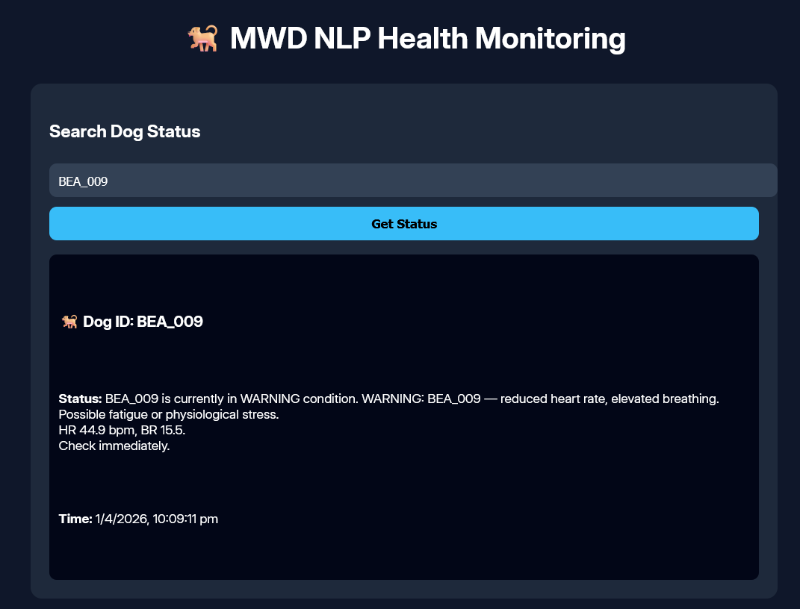
Figure 6: Real-time NLP-generated health status for an individual dog.

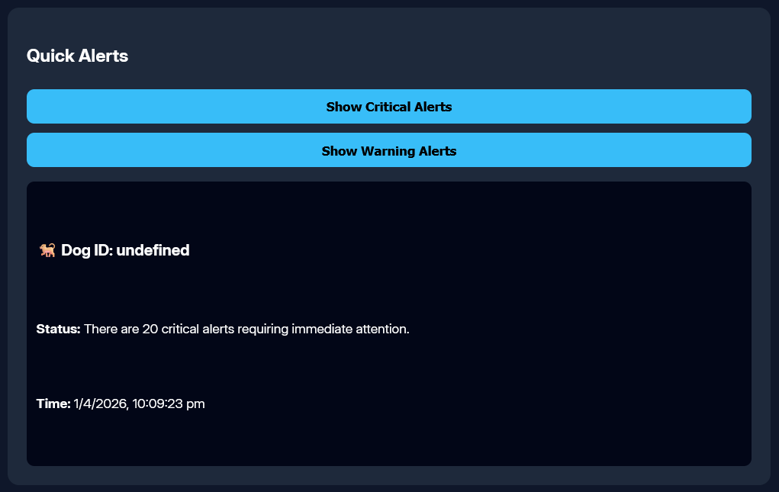
Figure 7: Aggregated critical and warning alerts across multiple dogs.
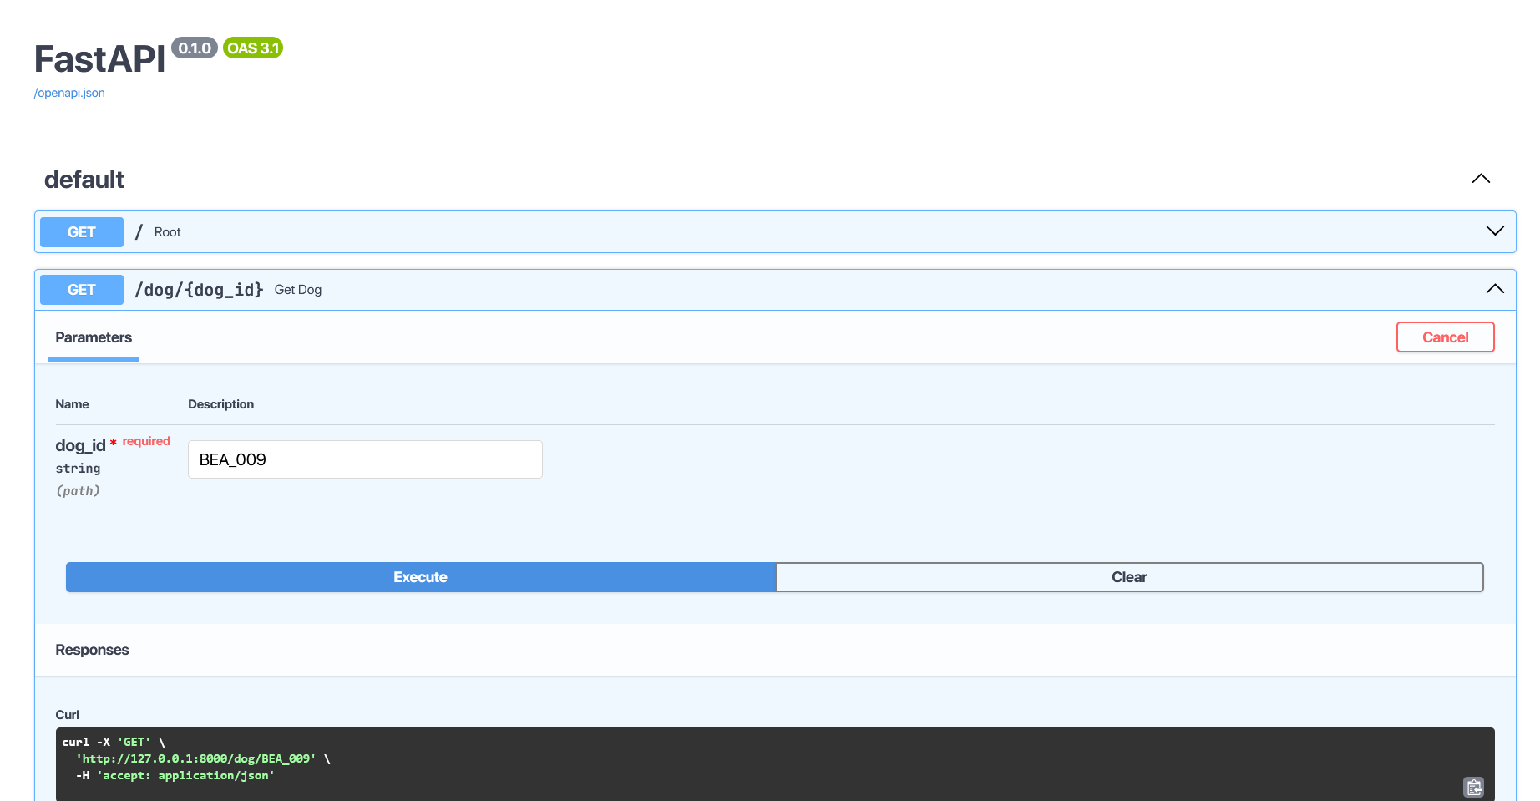
Figure 8: API response showing generated natural language alert for a queried dog.
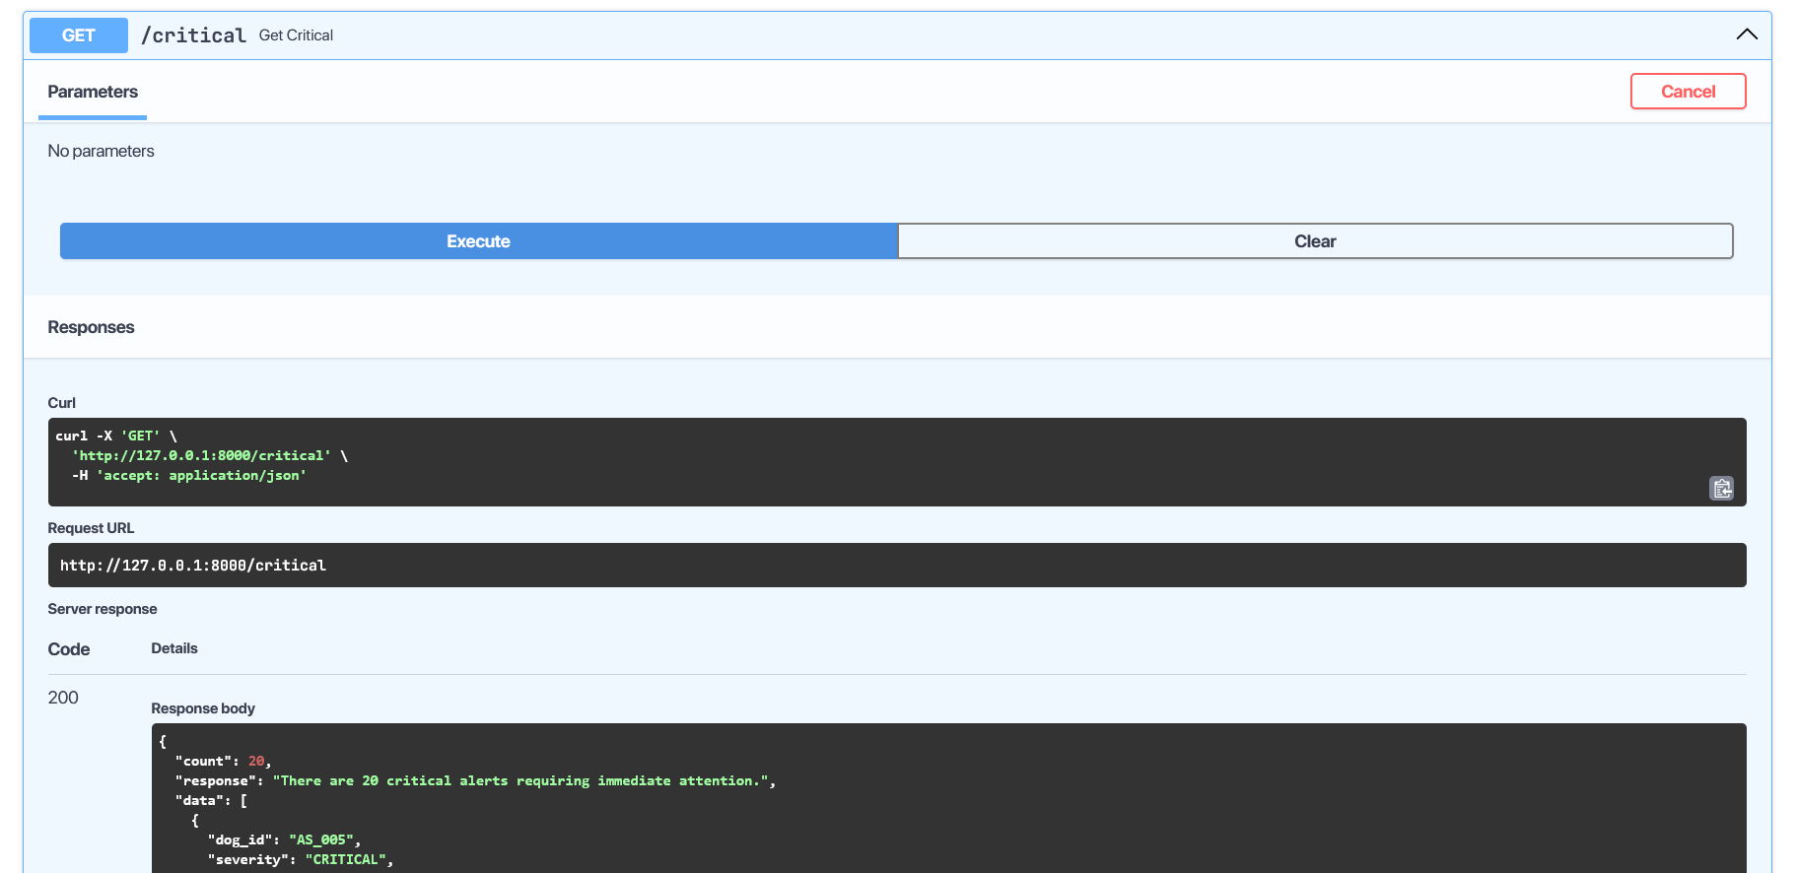
Figure 9: API output demonstrating batch anomaly alerts for multiple dogs.

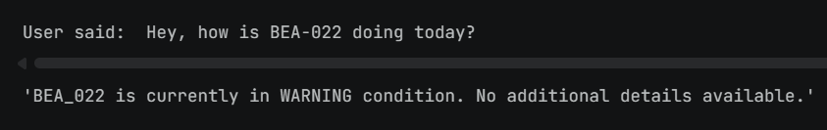
Figure 10: Voice query processed into a natural language system response.
Across the evaluation:
- Anomaly detection (hybrid threshold + RF): F1 = 0.87 on simulated data.
- NLG alert quality: BERTScore F1 = 0.83 vs. human-written references.
- End-to-end latency: NLG inference under 500 ms (CPU), voice round-trip ~1.8 s.
- Usability pilot: 5 participants, 38% faster correct responses with NLP alerts vs. raw sensor output.
Taken together, the results suggest this architecture is sound and worth pursuing further. The next step is validation on real collar hardware in field-like conditions.
12. What Aspect(s) of the Invention Need(s) Protection?
- The software-implemented sensor-to-language transformation pipeline configured to convert structured physiological sensor data into contextual natural language outputs, comprising preprocessing, anomaly detection, prompt construction, and transformer-based generation.
- The method of generating structured event representations from multi-sensor physiological inputs and transforming said representations into controlled prompts for natural language generation.
- The hybrid anomaly detection framework combining rule-based thresholding and machine learning models for real-time identification of physiological anomalies in streaming data.
- The voice-driven interaction system integrating speech-to-text processing, intent extraction, real-time data retrieval, and dynamic natural language response generation.
- The modular orchestration architecture enabling integration of sensor ingestion, anomaly detection, language generation, and voice interaction through an API-based pipeline.
13. What is the Technology Readiness Level of your invention? (Tick the appropriate TRL)

Research |  |  | Development |  |  | Deployment
TRL 1 | TRL 2 | TRL 3 | TRL 4 | TRL 5 | TRL 6 | TRL 7 | TRL 8 | TRL 9
Basic Principles observed | Technology concept formulated | Experimental proof of concept | Technology validated in a lab | Technology validated in relevant environment | Technology demonstrated in relevant environment | System prototype demonstration in operational environment | System complete and qualified | Actual system proven in operational environment
✓ | ✓ | ✓

Current Status: TRL 1–3 (Basic principles observed, technology concept formulated, experimental proof of concept). The system architecture has been designed and validated in a simulated software environment. Hardware integration and real-collar testing represent the next development phase (TRL 4).

-----------------------------END OF THE DOCUMENT------------------------------

